**Texas International College**



**Tribhuvan University**

**Faculty of Humanities and Social Science**

**LIBRARY MANAGEMENT SYSTEM**

**A PROJECT REPORT**

**Submitted to**

**Department of Computer Application**

***In partial fulfillment of the requirements for the Bachelor of Computer Application***

**Submitted By**

Rojal Luitel(6-2-926-21-2020),

Rajak Putuwar(6-2-926-17-2020)

**BCA 4th, 2077 Batch**

# Introduction

A library management system is a web-based application designed to maintain, organize, and handle countless books systematically. It can track the numbers of books in the library, issued books, and returned books. If the due date is past, it has the function of charging the fine. The users can find the books in an instant and even reserve them through this system. This will help eliminate repetitive manual work and minimize the chance of errors and the immense use of paperwork. Earlier, the librarian used to manage the whole work in manual mode in the form of files and record books. Also, the process of adding new books, new users, issuing, and returning books had to be managed in a manual manner, which is very slow and inefficient. This application resolves this problem and provides a better solution. Users can access the system from any location with an internet connection to search for the required books. This web application can track the books taken by the user and their due date for return. And the users will also get notifications about the new arrival of books and about returning books.

# Problem Statement

In case of manual search of books, it experiences high cost of time loss for both librarian and user. Keeping of manual record may cause loss of record in case of any physical or natural harm. Managing records of incoming and outgoing of books manually is very tedious. Users get bad experience visiting library in search of same book repeatedly. Users have to loss their precious time just to know that the library doesn’t have a book that the user is seeking for.

# Objectives

Due to the problem in the manual library management we propose this system with the following objectives:

* To reduce the time cost of both parties i.e. librarian and users using computerized system.
* To search the books easily with easy update and adding in database.
* To remove the need of validation of the same user frequently.

# Methodology

## Study of Existing System:

Before we build our project, we first analyze other existing systems.

* + 1. **Destiny Library Manager**

Library management system that you can access 24*7 from anywhere anytime. It can also build a various print and digital resources by keeping in mind every kind of students. not only for students the destiny library system also provides customizable tools, extensive collection of books for teachers also. It can be locally installed as well as Follet-hosted.

* + 1. **Blackboard Library Management:**

It is one of the library management used in Nepal. It has the most of the exiting features. dashboard that displays a wide range of information about the operations of the school library. The system organizes books by the level of reading, determines the reading level of each book, determines the genre for each book. The library management system allows students to borrow books from the library when they need them. System has a history with books in the library starting with writing development and other inventions like paper and book printing.

## Feasibility Study

## Technical Feasibility:

HTML/CSS is used for frontend and Laravel is user for backend, MySQL for database.

Hardware to operate like laptop and mobile with web browser installed.

## Operational Feasibility:

**Scalability:** we can later on expand the project we can make it online.

**Portability**: we can run on any eligible device and mobile app too.

**User**-**friendly**: Our design is optimal and optimized so, end user can easily understand and use the interface.

## High Level Design



*Fig 4.3.1.: Context Level Diagram of Library Management System*

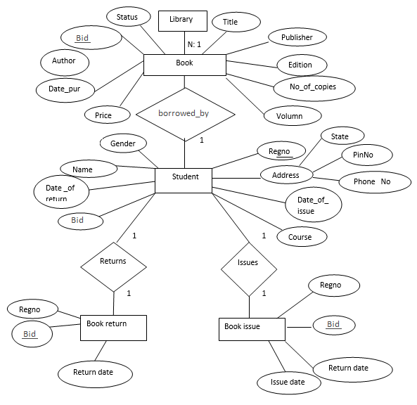

*Fig 4.3.2: ER diagram of Library Management System*

# Gantt Chart

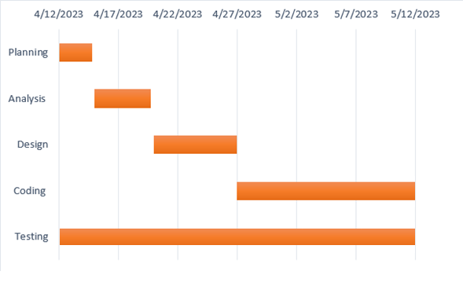

Fig 5.1: Gantt Chart

# Expected Outcome

This project can deliver the following outcomes:

Using the library management system, we can easily know the availability of the new arrivals as well as the books in the library. Easy management of ingoing and outgoing of books. We expect to manage the books automatically through computers, so there is no need to manage them manually. It helps to reduce time as well as effort time to search the books availability in the library. Being an automated system, it does not require external human resources to find the books in the library. Instead, we can search through computers.

# Bibliography

* Javed, M, & Raza, S. (2017). Development of a Web-Based Library Management System Using PHP and MySQL. International Journal of Computer Applications, 160(4).
* "follettlearning," [Online]. Available: https://www.follettlearning.com/education-technology/library-management-system. [Accessed 11 04 2023].
* "blackboard," [Online]. Available: "follettlearning," [Online]. Available: https://www.follettlearning.com/education-technology/library-management-system. [Accessed 11 04 2023]